**9.1: Explain the impact of changing markets and new opportunities. (P1 – Task 6)**

**Part 1: Decline in Traditional Market Sectors and Developments in Others**

|  |  |  |  |
| --- | --- | --- | --- |
| **Type of shop** | **Description** | **Examples** | **Giving an example, write an explanation of whether you think this type of shop is currently in decline or developing. Explain your reasoning.** |
| **Brick and Click** | **A shop that has a real store and an online one** | **Argos** | **Developing, as some people do not like the hassle of going into store and buy online, others prefer to go there in person** |
| **‘Brick’ only** | **A physical shop** | **Poundbakery** | **Decline, as they will have less customers than brick and click stores.** |
| **Independent** | **A standalone shop with a single branch** | **A corner shop** | **Decline, as large retail companies and businesses are the new go to and are more reliable.** |
| **Online Only** | **Only online shop** | **Ebay** | **Developing, as we are currently in a technological era where online is most people's go to for most things as it is more accessible.** |

**How have changes in computing affected the development or decline of Bury College, or how could it affect the College in future?**

|  |
| --- |
| **Areas of growth in education: more efficient online learning, AI teachers, it will focus more on the cloud, shifting towards lifelong learning instead of thinking of short-term benefits** |
| **Areas of decline in education: traditional courses will die out and jobs will not be taken as they do not pay much or appeal to people** |
| **Possible impact upon Bury College: More online learning and classes, more flexible timetables as there won’t be a need to book rooms, some teachers may be fired as their skills aren't needed for online lessons, the more practical courses won't be taught properly such as drama and engineering.** |

**Part 2: The need for organisations and businesses to develop and change to take advantage of new markets and new opportunities**

Companies entering new markets. An example of this is Apple, they were originally known for making computers called ‘Macintosh’ and they branched out into making mobile phones known as ‘iPhone’. This was very successful as it is one of the biggest brands in the world now and it has a much larger influence than it originally had, they still make computers and laptops, but their primary product is iPhones.

Another example of this is Windows, they were originally known for making operating systems for PC, and they still are, but they have branched out into making phones known as ‘windows phones’ this is a new OS for mobile. This was very successful as it is still one of the leading operating systems in the world that is used by many due to its low learning curve and ease of use, the windows phone is one of the world's leading operating systems for mobile behind iOS and Android.

Another example of this is Google, they are well known for making the google search engine for exploring the internet, but they have branched out into 2 new markets, Google+ and Google Pixel. Google+ is a social network that was intended to be part Twitter and Facebook, but it died out as no one used it. Google pixel on the other hand is still a very famous line of phones that come out every year with top end flagship devices. Google+ was not successful as it is not used by anyone. Google Pixel was successful as it still has a market of users who buy the new devices.

Another Example of this is Amazon, they are mostly known for their online shopping platform, but they have branched out into media with Amazon Fire. Amazon Fire is a streaming device that can be connected into any tv with a HDMI port to essentially turn it into a smart tv and use apps such as YouTube and Netflix. This was very successful as it is one of the leading devices in this field along with Google Chromecast.

Another example of this is Apple, they were originally known for making computers called ‘Macintosh’ and they branched out into making mobile phones known as ‘iPhone’ but they also branched out into making ‘Apple Arcade’. This is similar to ‘Xbox game pass’ in that it allows you to play games across all your apple devices. This was not very successful, as although it has a steady stream of users it has not produced any large triple A titles or big hits.

**How has this affected Bury College, or how could it affect the College in future?**

This won't affect college in the future unless it decides to break into a new market which they probably won't as they are focused on education, but they could potentially create education resources such as textbooks and revision guides. This would result in college having more income and funding.

**Part 3: Balancing growth in some areas against decline in others, e.g. traditional retail, analogue**

**music and photography versus digital**

Cashiers, this job is of a very low skill ceiling and is undertaken by supermarket workers who scan your groceries have been removed in many places and overtaken by self-service scanning and checkout.

Factory workers, this job is very hard manual labour that is of low skill as it doesn’t require any qualifications or prior experience. The job consists of packaging many objects or assembling them. This has been overtaken by robotic devices that can automatically assemble and pack object at a much higher efficiency than humans can.

Lift operators who used to pull ropes to lift up the lifts to higher floors have been overtaken by machines that can do this which are much safer. This job was not of a high skill level however it was very demanding physically.

Bowling alley pinsetters were people who arranged the bowling pins before you played a round of bowling, this was a low skill job that has been overtaken by machines that collect and reset your pins at the end of every round.

One job that will be created by developments in computing will be an Ethical sourcing officer will be a mid-skilled job that will have to make sure that companies are being ethical.

Another job that will be created by developments in computing will be an Artificial intelligence business development manager, this is a average skilled job that will be used to market and sell AI to others as for the foreseeable future ai won't be able to sell themselves to consumers.

Another job that will be created by developments in computing will be a Master of edge computing, this is an average skilled job that will work on help companies store data in connected hardware devices instead of on a server or data centre.

Another job that will be created by developments in computing will be a Walker/talker, this will be a low skill job that consists of walking with people and talking to them when they feel lonely, the customers will mainly consist of the elderly.

In conclusion jobs of a low skill that consist of a lot of manual labour and heavy lifting will soon be overtaken by developments in computing and robotics and the jobs that will be created are jobs that can only be done by humans with no chance of being overtaken by AI.

**How has this affected Bury College, or how could it affect the College in future?**

**Part 4: Potential provided by developments in IT for cost reductions, improved customer service**

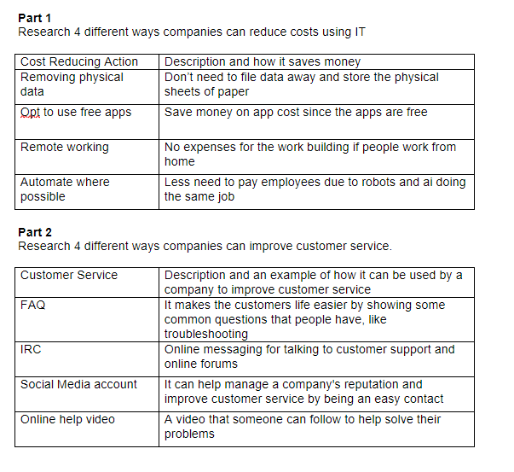

**How has this affected Bury College, or how could it affect the College in future?**